**Extraction of Aluminium price from a website**

|  |  |
| --- | --- |
| **Document Dates** | 19-09-2024 |
| **Prepaid by** | Saket Verma |
| **Version** | v1 |
| **Status** | Not started |
| **Solman No** |  |

***Objective:***To extract tabular price data from given website and stored as excel file

Website link - <https://nalcoindia.com/domestic/current-price/>

Price link - [https://d2ah634u9nypif.cloudfront.net/wp-](https://d2ah634u9nypif.cloudfront.net/wp-content/uploads/2019/01/Ingot-17-09-2024.pdf)content/uploads/2019/01/Ingot-17-09-2024.pdf

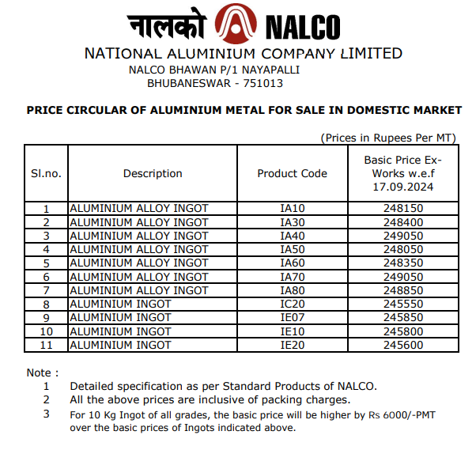

***Project*** ***Overview :***

Extraction of tabular price data from a pdf file using python with an automated feature that can be schedule.

***Functional Requirements***

* **Data Sources:** nalcoindia.com
* **Data Format:** Csv file

#### **Technical Requirements**

* **Programming Language:** Python
* **Development Environment:** google colab, jupyter notebook, anaconda

***Outcome:***

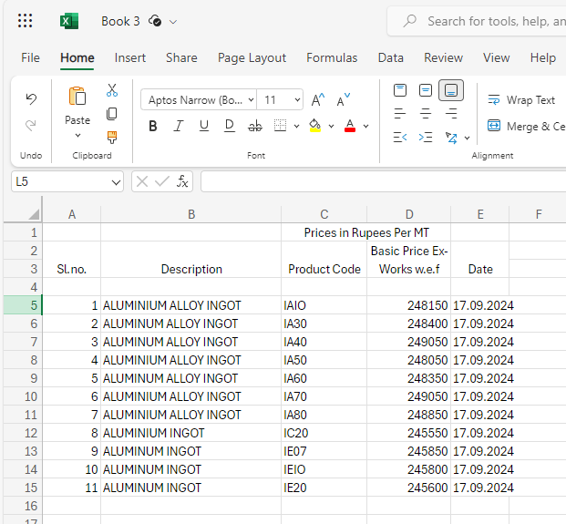

**Extraction of Aluminium price from a website**

|  |  |
| --- | --- |
| **Document Dates** | 23-10-2024 |
| **Prepaid by** | Saket Verma |
| **Version** | v2 |
| **Status** | Started |
| **Solman No** |  |

Update the **Combined_data file** using the **BigMint_Assessment_Prices file** from the FTP server. Change the dates in **Combined_data** for entries from **BigMint_Assessment_Prices** based on the following timestamps:

* 9:25 AM: Current date; all other dates remain unchanged.
* 12:10 PM: FTP date; all other dates remain unchanged.
* 2:25 PM: FTP date; all other dates remain unchanged.
* 5:10 PM: FTP date; all other dates remain unchanged

**Extraction of Aluminium price from a website**

|  |  |
| --- | --- |
| **Document Dates** | 24-10-2024 |
| **Prepaid by** | Saket Verma |
| **Version** | v3 |
| **Status** | Started |
| **Solman No** |  |

The domain of the aluminium wire rod file was constantly changing. To address this, I implemented a pattern search to facilitate updates. I needed to make multiple changes across interconnected files, which took up most of my day.